DEVOPS MINI PROJECT 3-UNIT

Enterprise Smart Library Management Platform

DevOps Foundation, Version Control, Continuous Integration & Container Orchestration

Name | Aditi Prabhakar Pabale
PRN | 2125UDSF1080
Class | SY-AIDS
Topic | Enterprise Smart Library Management Platform: DevOps, Version Control, CI & Container Orchestration
Environment | Python · Flask · Pytest · Jenkins · Docker · Minikube

GIT HUB LINK: https://github.com/aditipabale29-ship-it/enterprise-student-academic-platform.git

Executive Summary & Engineering Context

In enterprise software engineering, bridging the traditional chasm between application development and operational stability is paramount. Prior academic phases established requirements gathering, backlog grooming, and Agile sprint planning. Unit 3 marks the crucial transition from conceptual design to production-grade engineering practices.
DevOps is fundamentally not merely an assortment of automation utilities; it represents an institutional engineering culture and methodology designed to integrate developers, quality assurance engineers, and IT operations into an agile, highly automated continuum. Rather than treating software deployment as an afterthought, enterprise engineering treats the build, validation, packaging, and hosting pipeline as code.
This document provides a theoretical foundation for the Enterprise Smart Library Management Platform. It articulates the business imperatives driving DevOps adoption, contrasts traditional waterfall IT with modern CI/CD, breaks down the complete eight-stage DevOps lifecycle, details distributed version control mechanics in Git/GitHub, explains Continuous Integration (CI) with Jenkins, and analyzes containerization with Docker and orchestration via Kubernetes (Minikube).

C O R E A R C H I T E C T U R A L O B J E C T I V E
DevOps bridges development and operations through Culture, Automation, Measurement, and Sharing (CAMS).
The primary engineering objective is reducing Cycle Time (from commit to customer) while increasing Deployment Frequency, Stability, and Mean Time to Recovery (MTTR).

Project at a Glance

Attribute | Details
Target Platform | Enterprise Smart Library Management Platform (Python / Flask / Pytest / Jenkins / Docker / Minikube)
Student Parallel System | Enterprise Student Record & Academic Management Platform
Document Purpose | Academic and professional DevOps theoretical framework, architecture and engineering principles
Version & Status | v1.0.0 Production Release: Comprehensive Academic Manual

The Business Need for DevOps

The Traditional Software Delivery Dilemma
Historically, software engineering organizations operated in rigid organizational silos. The development team was incentivized by business stakeholders to rapidly write new features, while the IT operations team was incentivized to maintain infrastructure stability, uptime, and strict change control.
This misalignment generated what industry pioneers describe as the “Wall of Confusion”. The traditional sequential delivery model (Waterfall) proceeded through protracted phases:
    - Requirements Silo: Requirements were locked down months in advance, leaving no room for market agility.
    - Development Silo: Software engineers worked in isolation, without visibility into production server configurations.
    - Testing Silo: Large, infrequent batches of code were thrown over the wall to QA for manual verification.
    - Operations Silo: Sysadmins received release packages with extensive, error-prone manual runbooks.
    - Maintenance Silo: Unmonitored bugs and performance degradations escalated into midnight outages and stressful blame games.
Key systemic pathologies of traditional IT include:
    - Environment Drift: The “Works on My Machine” syndrome, where applications operate on developer workstations but crash on staging or production due to subtle environment discrepancies.
    - Integration Hell: Merging months of unintegrated work resulted in weeks of merge conflicts and regressions.
    - Error-Prone Manual Releases: Manual SSH scripts, FTP uploads, and manual configuration tweaks yielded high change failure rates.
    - Protracted Downtime & Rollback Risks: When a production defect emerged, rolling back required recreating complex database states and restoring monolithic servers.

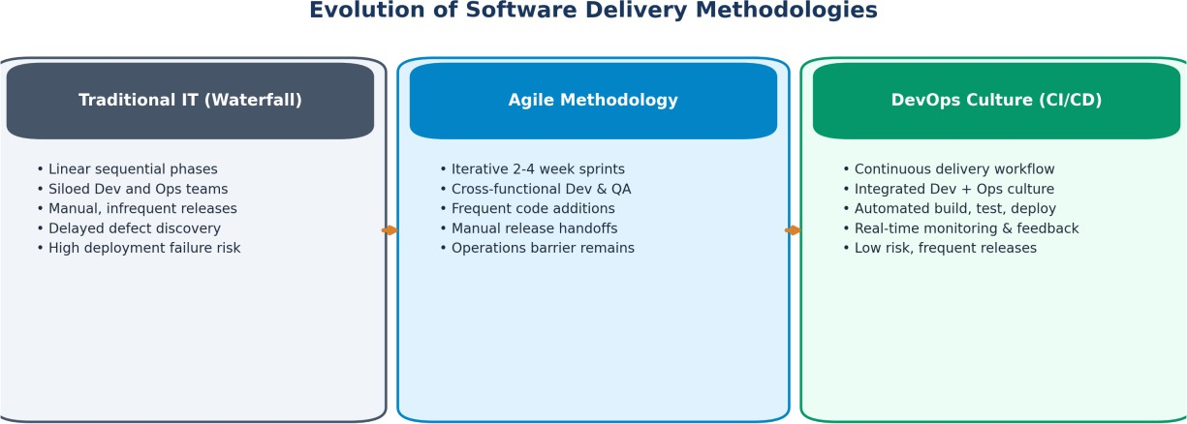
Figure 1: Evolution of Software Delivery Methodologies from Traditional IT to Agile and DevOps

Comparative Evolution: Traditional IT vs. Agile vs. DevOps
While Agile principles significantly improved project management and developer responsiveness by breaking monolithic requirements into 2-to-4 week sprints, Agile alone stopped at the boundary of working software on a developer’s workstation. It failed to address the downstream friction of deployment, configuration management, and runtime reliability. DevOps completes the transformation.

Engineering Dimension | Traditional IT (Waterfall) | Agile Methodology | DevOps Framework (CI/CD)
Delivery Rhythm | Sequential, monolithic (months / quarters) | Iterative sprints (2 to 4 weeks) | Continuous, on-demand (multiple daily releases)
Organizational Structure | Strictly siloed Dev, QA, and Ops teams | Cross-functional Dev & QA teams | Integrated cross-functional Product & DevOps teams
Deployment Method | Manual checklist, fragile shell scripts | Manual or partially automated at sprint end | Fully automated, immutable CI/CD pipelines
Environment Parity | Frequent drift between Dev, QA, & Prod | Staging environments diverge from Prod | Guaranteed parity via Docker containers & IaC
Quality Verification | Post-development manual regression testing | Sprint-based manual & automated testing | Continuous shift-left automated tests on every commit
Feedback & Telemetry | Periodic customer surveys, post-mortems | Sprint review and retrospective meetings | Real-time automated metrics, logs, and APM alerting
Change Failure & Risk | High blast radius; catastrophic rollbacks | Moderate risk localized to sprint drops | Low blast radius; instant rollback via blue/green or canary

The End-to-End DevOps Lifecycle

The DevOps lifecycle is modeled as an infinite loop rather than a linear sequence, underscoring that modern software engineering is an iterative, continuous feedback mechanism. Every production observation immediately informs future architecture and backlog planning.

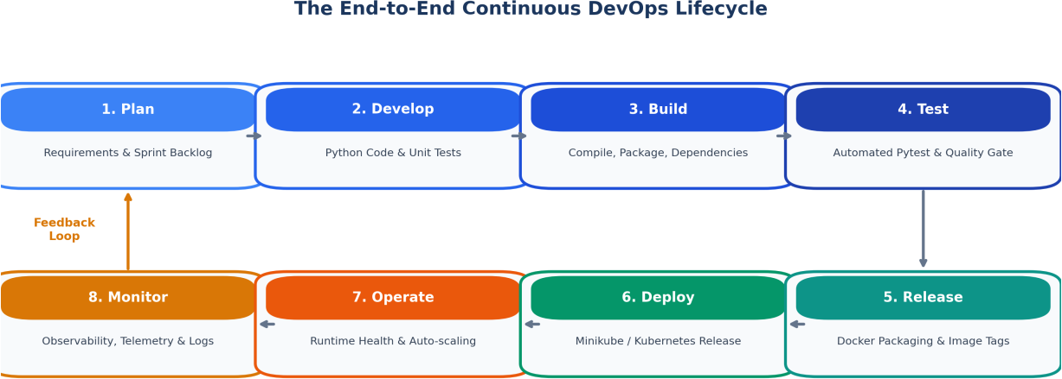
Figure 2: The Infinite Continuous DevOps Engineering Lifecycle

Lifecycle Phase Breakdown
    - Phase 1 - Plan: Engineers and product owners analyze business requirements, user stories, and acceptance criteria. Tasks are broken into small increments and tracked via backlogs (Jira, GitHub Issues, Kanban boards). Security and scalability requirements are defined.
    - Phase 2 - Develop (Code): Engineers write modular, clean Python code within IDEs. Code is version-controlled in short-lived Git feature branches. Pair programming, local linting (flake8, black), and pre-commit hooks ensure baseline quality.
    - Phase 3 - Build: Automated builds compile code, isolate runtime dependencies, and assemble immutable build artifacts. In Python, this means creating clean virtual environments, resolving requirements.txt, and validating syntax across all packages.
    - Phase 4 - Test: CI servers execute automated unit tests, integration tests, and static code quality analysis (pytest, coverage, SonarQube). Builds fail immediately if any test fails (“Shift-Left Testing”).
    - Phase 5 - Release: Validated artifacts are bundled into versioned Docker images, tagged with semantic version numbers (e.g., v1.0.0, commit SHA), and pushed to a container registry (Docker Hub, Amazon ECR, Harbor).
    - Phase 6 - Deploy: The containerized application is deployed to staging or production runtime infrastructure (Kubernetes clusters, Minikube). Rolling updates ensure zero downtime for end users.
    - Phase 7 - Operate: Infrastructure and application health are managed actively. Auto-scalers adjust replica counts based on CPU/memory pressure, while connection pools, caches, and load balancers maintain throughput.
    - Phase 8 - Monitor: Distributed tracing, metrics, and centralized log aggregation (Prometheus, Grafana, ELK Stack, Datadog) track runtime performance. Synthetic health checks and alert thresholds trigger instant root-cause analysis.
S H I F T - L E F T T E S T I N G P A R A D I G M
The financial and operational cost of defect remediation increases by roughly 10x with each lifecycle stage.
Catching bugs during local development or automated CI testing costs a fraction of diagnosing a high-severity incident in live production.

Version Control & Collaborative Git Workflows

Distributed Version Control Principles
Version Control Systems (VCS) record changes to files over time, enabling software engineers to recall specific versions, audit changes, and collaborate concurrently without destructive overwrites. Git, engineered by Linus Torvalds, is a Distributed Version Control System (DVCS). Unlike centralized systems (such as SVN or Perforce), every developer’s local machine hosts a complete clone of the repository history.

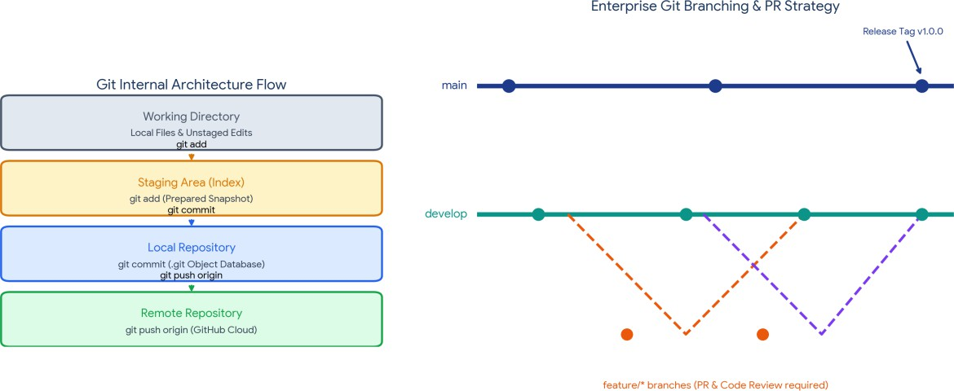
Figure 3: Git Internal Architectural Flow and Enterprise Feature-Branching Strategy

Git Four-Area Architecture
Git manages files across logical areas on a developer’s workstation before synchronizing with remote repositories:
    - 1. Working Directory: The physical file directory containing project code, configs, and assets where active editing occurs.
    - 2. Staging Area (Index): The .git/index file, a draft snapshot where selected modifications are prepared using “git add” prior to committing.
    - 3. Local Repository (.git): The hidden .git directory holding the object database (blobs, trees, commits, tags). “git commit” permanently records an immutable SHA-1 hashed snapshot.
    - 4. Remote Repository: A hosting platform (GitHub, GitLab, Bitbucket) that acts as the single source of truth for the team, updated via “git push”.

Comparative Matrix: Git vs. GitHub

Criterion | Git (Core Engine) | GitHub (Collaboration Platform)
Classification | Open-source distributed version control CLI tool | Cloud-based hosting, collaboration, and DevOps platform
Execution Location | Runs entirely locally on the developer’s computer | Hosted on cloud infrastructure (web GUI, REST APIs)
Network Dependency | Completely offline; commits, logs, branches need no internet | Requires internet to push, pull, review, or trigger webhooks
Primary Capabilities | Branching, merging, commit tracking, diff inspection | Pull requests, code review, issue tracking, project boards, Actions
Enterprise CI/CD Role | Versions source files and pipeline definitions | Houses source code and triggers Jenkins CI/CD via webhooks

Enterprise Branching Strategies
A structured branching strategy prevents unstable experimental code from polluting production systems. For enterprise platforms, a controlled Feature Branch Workflow is the industry standard:
    - main (Production Branch): Strictly protected branch reflecting production-ready, thoroughly validated code. Direct pushes are barred; merges require approved Pull Requests.
    - develop (Development Branch): Integration branch where completed feature branches converge for end-to-end integration and staging validation.
    - feature/* (Feature Branches): Short-lived branches cut from develop (e.g., feature/user-auth, feature/book-catalog). Developers commit frequently in isolation, then open a Pull Request.
    - hotfix/* (Urgent Fixes): Emergency branches cut directly from main to patch critical production defects, followed by immediate merge-back into both main and develop.

Continuous Integration & Jenkins

Theoretical Foundation of Continuous Integration
Continuous Integration is the software engineering discipline where team members integrate their work into the main codebase frequently (typically multiple times a day). Each integration is automatically verified by an automated build and test sequence.
Without CI, teams suffer from “Integration Hell”, a crippling condition where developers work in isolation for weeks, leading to massive merge conflicts, incompatible interface assumptions, and widespread breakage that halts progress.

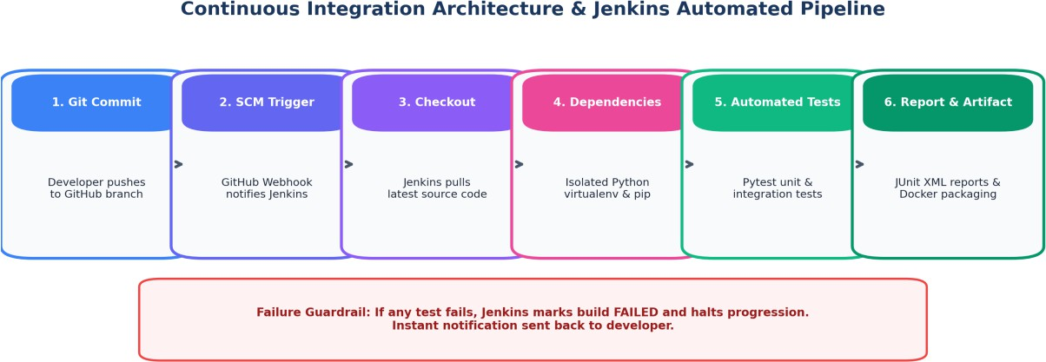
Figure 4: Continuous Integration Architecture & Jenkins Automated Pipeline Workflow

Anatomy of the CI Pipeline Stages
    - Stage 1 - Source Checkout: Jenkins receives a webhook from GitHub for a new push or pull request, and securely clones the exact commit SHA.
    - Stage 2 - Dependency Isolation: An isolated Python virtual environment is created, and pip installs the exact versions declared in requirements.txt.
    - Stage 3 - Linting & Static Analysis: flake8 and pylint verify syntax and PEP 8 standards, catching regressions without running the code.
    - Stage 4 - Automated Test Execution: pytest runs unit and integration tests. Assertions check data models, service business logic, and API endpoints.
    - Stage 5 - Quality Gate & Coverage: Reports are generated in JUnit XML and HTML formats. Code coverage must exceed a threshold (e.g., 85%).
    - Stage 6 - Artifact Packaging & Failure Guard: If every gate passes, the pipeline packages the Docker image or notifies the deployment manager. If any stage fails, the pipeline halts and alerts the committer.

Jenkins Architecture: Controller and Agent Model
Jenkins is the industry-standard, open-source automation engine. Its enterprise architecture follows a distributed Controller-Agent pattern:
    - Jenkins Controller (Master): Hosts the web interface, manages user authentication, schedules build jobs, monitors agents, and receives webhook notifications from GitHub.
    - Jenkins Build Agents (Workers): Lightweight worker instances (virtual machines, containers, or bare-metal servers) that run the resource-intensive build, test, and container packaging commands directed by the controller.

Component | Responsibility in This Project
GitHub Webhook | Notifies Jenkins on every push or pull request
Jenkins Controller | Schedules the pipeline and tracks build status
Jenkins Agent | Runs pip install, flake8, pytest, and docker build
Pytest Reports | JUnit XML and coverage output feed the quality gate

Containerization & Docker Architecture

Virtual Machines vs. Containers
Traditional IT deployed applications directly onto bare-metal operating systems or full Virtual Machines (VMs). Virtual machines require a Hypervisor (e.g., VMware, Hyper-V, KVM) that runs an entire Guest Operating System, including kernel, system drivers, and background daemons, for every application, consuming gigabytes of RAM and taking minutes to boot.
Docker revolutionizes software delivery through OS-level virtualization. Containers share the host kernel while isolating processes through two Linux kernel primitives:
    - Linux Namespaces: Strict process isolation through distinct virtual views of process IDs (PID), network interfaces (NET), mount points (MNT), and user IDs (USER).
    - Control Groups (cgroups): Resource governance that meters and caps memory, CPU, disk I/O, and network bandwidth for each container.

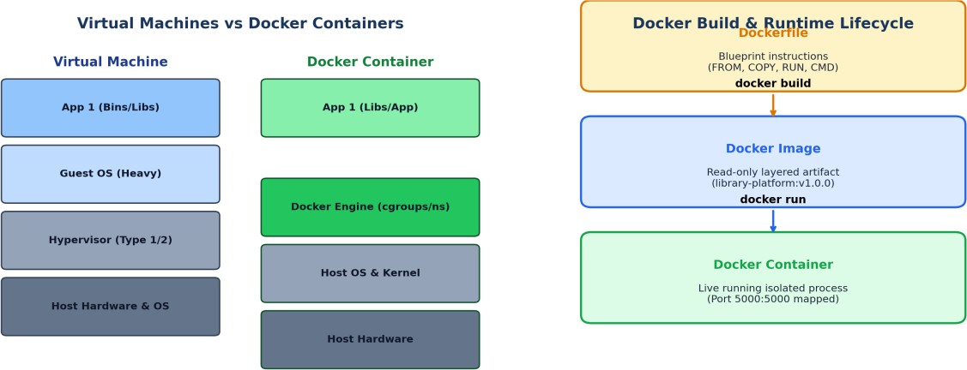
Figure 5: Architectural Comparison between Virtual Machines and Docker Containers alongside Build Lifecycle

Comparative Architecture: VMs vs. Containers

Architectural Attribute | Virtual Machines (VMware / KVM) | Docker Containers
Virtualization Level | Hardware-level (via Hypervisor) | Operating System-level (via Docker Engine)
Operating System Kernel | Each VM runs a complete, independent Guest OS kernel | Containers share the host operating system kernel
Startup Latency | Minutes (full OS initialization & bootloader) | Milliseconds to seconds (instant process execution)
Resource Footprint | Heavyweight (several gigabytes per VM image) | Lightweight (tens to hundreds of megabytes per image)
Density & Scalability | Low density (tens of VMs per high-end server) | High density (hundreds of containers per server)
Portability Guarantee | Subject to hypervisor formats and VM templates | Write once, run anywhere (OCI standards)

Docker Image Layering and Immutability
A Docker Image is an immutable, read-only template built from the instructions in a Dockerfile. Each instruction (FROM, COPY, RUN) creates an independent, content-addressable layer. Docker uses an Overlay File System (OverlayFS) with Copy-on-Write (CoW) mechanics:
    - Layer Caching: Identical base layers (such as python:3.11-slim) are shared across multiple images on the host, saving disk space.
    - Build Optimization: During “docker build”, Docker skips re-executing unchanged instructions, so subsequent builds finish in fractions of a second.
    - Container Layer: When a container runs, Docker places a thin, ephemeral read-write layer on top of the immutable read-only image layers.

W H Y I T M A T T E R S
Because images are immutable, the exact artifact that passes CI is the exact artifact that runs in Minikube. This removes environment drift and the “Works on My Machine” problem.

Kubernetes & Minikube Orchestration

Why Orchestration is Essential in Production
Docker provides an excellent format for packaging and running individual containers, but enterprise production demands managing hundreds of interacting containers across server fleets. Standalone Docker cannot natively handle:
    - Self-Healing & Auto-Restart: Containers terminate on process crashes; production requires automatic detection and recreation.
    - Dynamic Horizontal Scaling: Traffic surges require scaling from 2 to 20 replicas and distributing requests evenly.
    - Zero-Downtime Rolling Releases: New versions must deploy without dropping active connections, with instant rollback if errors occur.
    - Service Discovery & Load Balancing: Containers get new IP addresses when recreated; clients need a permanent, DNS-addressable entry point.

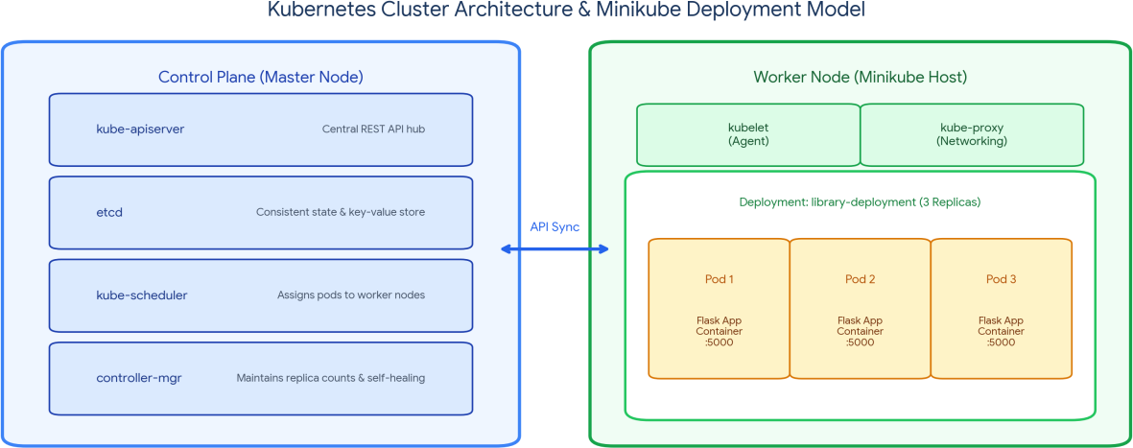
Figure 6: Kubernetes Cluster Architecture & Minikube Deployment Model

Kubernetes Architecture & Core API Primitives
Kubernetes orchestrates applications via a distributed Control Plane and Worker Nodes:
    - kube-apiserver: The REST API gateway exposing cluster administration endpoints for the kubectl CLI and internal controllers.
    - etcd: Highly available distributed key-value store holding cluster state, configurations, and secrets.
    - kube-scheduler: Watches for unassigned Pods and schedules them onto Worker Nodes based on resource availability.
    - kube-controller-manager: Enforces the declared cluster state (e.g., maintaining replica counts, handling node failures).
    - kubelet: Node agent that talks to the API Server and manages containers through the container runtime (containerd).
    - kube-proxy: Network proxy that maintains network rules and load-balances traffic across pods.
The fundamental API objects used in this project:

Object | Role
Pod | Smallest deployable unit in Kubernetes, wrapping one or more tightly coupled containers that share storage and network namespaces.
Deployment | Declarative controller that manages ReplicaSets, keeps the specified number of Pod replicas healthy, and handles zero-downtime rolling updates.
Service | Stable networking abstraction giving a single IP, DNS name, and load balancer in front of dynamic Pod replicas (ClusterIP, NodePort, LoadBalancer).

The Integrated DevOps Ecosystem

The entire automated software lifecycle converges when Git, Jenkins, Docker, and Kubernetes operate as one cohesive continuous delivery system.

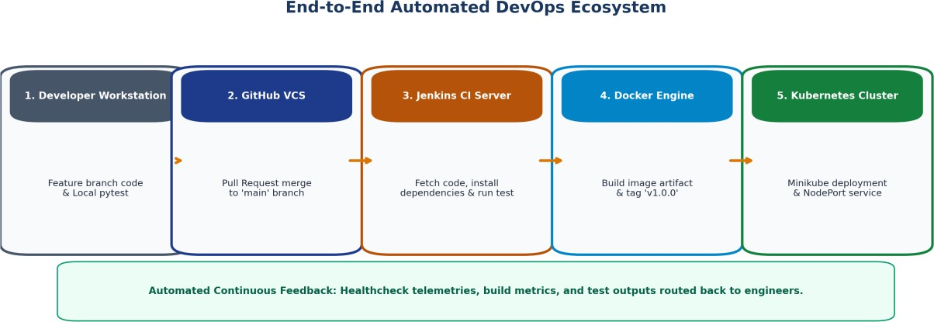
Figure 7: End-to-End Automated DevOps Ecosystem Architecture

The Complete Automated Path to Production
Step 1: Developer pushes code to a feature branch on GitHub and opens a Pull Request.
Step 2: GitHub Webhook triggers Jenkins; Jenkins pulls the code, runs static linting, and executes the pytest suites.
Step 3: After Pull Request approval and merge into main, Jenkins runs the deployment pipeline.
Step 4: Jenkins triggers Docker to build a production image with a unique version tag (v1.0.0).
Step 5: The image is pushed to the container registry, making the release artifact globally accessible.
Step 6: Jenkins applies the Kubernetes manifests (kubectl apply -f k8s/), triggering a rolling update on Minikube.
Step 7: Kubernetes provisions new Pods, runs readiness health checks, routes traffic through the NodePort service, and gracefully terminates old containers.
Step 8: Metrics, logs, and health status flow into monitoring dashboards, completing the continuous feedback loop.

Academic Project Alignment: Trainer vs. Student Implementations

Lifecycle Phase | Trainer Implementation (Case Study) | Student Project (Independent Implementation)
Domain Application | Enterprise Smart Library Management Platform | Enterprise Student Record & Academic Management Platform
Core Business Entities | Books, Borrowers, Inventory, Loans, Overdue Fines | Students, Courses, Faculty, Enrollments, Academic Marks
Validation Modules | Book checkouts, duplicate ISBNs, membership rules | Course registrations, student lookups, grade GPAs
CI Test Coverage | tests/test_book_service.py, tests/test_borrow_return.py | tests/test_student_service.py, tests/test_marks_mgmt.py
Packaging & Deployment | Docker image: library-platform:v1.0.0 on Minikube | Docker image: student-platform:v1.0.0 on Minikube
C O N C L U S I O N
Git, Jenkins, Docker, and Kubernetes together turn a commit into a running, monitored release with no manual hand-offs. The same pipeline pattern applies unchanged to the library platform and to the student record platform.

